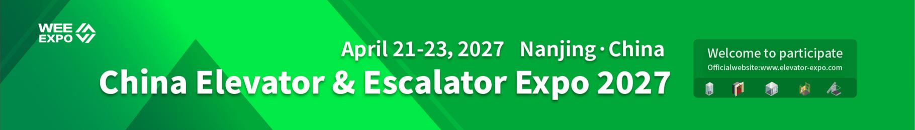


Langfang Conference & Exhibition Co., Ltd

1.Basic information of the registered company
Company Name
Contact Address
Country |  | Tel (WhatsApp)
Contact people |  | E-mail
Web |  | City
Application booth area:____㎡

2.Booth type and price
Type | Price
Raw Space | 250$ /㎡/exhibition period, minimum order of 48㎡
Standard booth | $3,240/12㎡/exhibition period (which includes a $20 per㎡booth building fee)
Standard booth configuration description
（1）Area: 12 square meters (3 meters * 4 meters), height 2.5 meters
（2）Booth panels: white standard frame, 3-sided panels (for double-sided booths, there are 2-sided panels)
（3）Nameplate (Chinese and English name, booth number) - 1 piece (2 nameplates for double-sided booths)
（4）Consultation desk - 1 piece
（5）Meeting chairs - 2 pieces

（6）Short spotlight (100w) - 2 pieces
（7）Power socket (220v/5A) - 1 unit
（8）Trash can - 1 unit
（9）Carpet - 12 square meters

3.Product list
Complete machine
Passenger elevator Villa elevator Special elevator
Sightseeing elevator Medical elevator Moving walkway
Freight elevator Vehicle elevator Mine elevator
Escalator Cargo elevator Related industries
Acessory
Towing drive system Guide rail system Elevator car
door system Weight balancing system Electrical control system
Elevator decoration Security and the Internet of Things Protective equipment hydraulic system
Protective equipment Escalator accessories Small accessories
Other components Safety protection system
Parking exhibition area
Smart parking equipment Mechanical parking area
Intelligent Parking Management System
Intelligent Parking Charging System Intelligent parking assist product
3D Parking Management System
Parking lot related facilities Parking accessories
New energy vehicle charging and swapping system Parking Security Series

4.Booth display
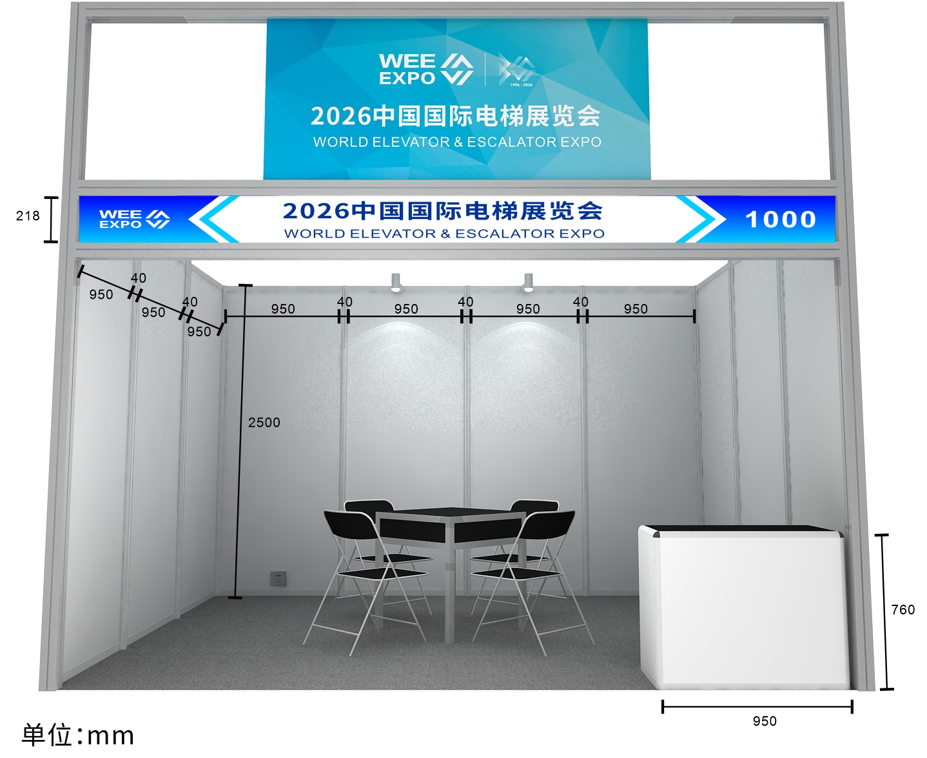 | 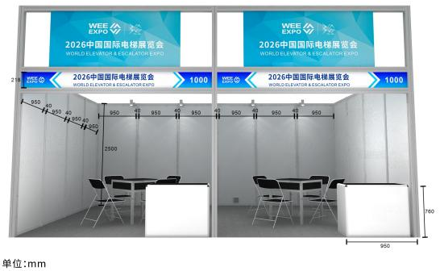 | 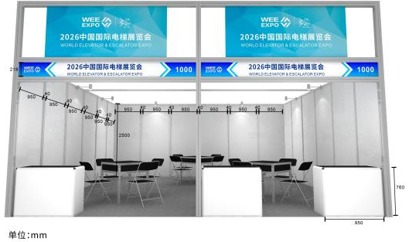
3m x 4m Booth display | 4m x 6m Booth display | 6m x 6m Booth display
Langfang Conference & Exhibition Co., Ltd

5.Exhibitor’s Signature & Seal Confirmation Section
Langfang Conference & Exhibition Co., Ltd.
Add：No. 2 Guangyang East Road, Guangyang District, Langfang City, Hebei Province
Contact person：Wu Peng
Remittance unit: Langfang Conference and Exhibition Co., Ltd.
Account number：1001 4858 3187
Bank of Account: Bank of China Langfang Development Zone Branch
Tel(WhatsApp)：+86 18033672021
+86 316 6078901 6078902 6078325
LinkedIn：WEE EXPO COMPANY
E-mail：data@elevator-expo.com
Stamp: Signature:
Date:

